**Student Grade Report System**

A **C++ console-based project** that manages student records, calculates percentages, assigns grades, and provides various update/delete functionalities. This project demonstrates dynamic memory allocation, arrays, file handling, sorting, and data manipulation in C++.

**Features**

* Add student records (Roll No, CS marks, Math marks, Name).
* Calculate percentage and assign grades automatically.
* Display results in a tabular format.
* Update roll numbers or marks (individual or batch).
* Sort students by percentage (ascending order).
* Delete a student’s record by roll number.
* Save results to data.txt.
* Change console colors for a better UI.

**Topics Covered in This Project**

✔️ Dynamic Memory Allocation (new, delete)  
✔️ Arrays & Pointers  
✔️ Functions & Modular Programming  
✔️ File Handling (ofstream)  
✔️ Console UI (Windows.h, system commands, Sleep)  
✔️ Sorting Algorithm (Bubble sort logic)  
✔️ Input Validation & Error Handling

**How to Run**

1. Clone this repository:
2. git clone https://github.com/Muneeb-techpro/student-grade-report.git
3. Open the project in **Visual Studio** or any C++ IDE.
4. Compile and run:
5. g++ main.cpp -o grade_report
6. ./grade_report

**Functionality Description**

**1. arrayofrollnum(int* oldarr, int size)**

Dynamically resizes the roll number array when adding new students.

**2. array_percentage_num(int* arr_cs, int* arr_math, int size)**

Calculates percentage for each student based on CS and Math marks.

**3. array_grade(double* arr_percentage, int size)**

Assigns grade (A, B, C, D, F) based on percentage ranges.

**4. templete_display(...)**

Displays student records in a formatted table (without names).

**5. final_templete_display(...)**

Displays **final record** (with student names) and writes to data.txt.

**6. update_roll_num(int* arr_roll, int size)**

Updates the roll number of a student.

**7. update_cs_math(...)**

Updates **marks** (CS/Math) of a single student.

**8. update_all_cs_math(...)**

Updates marks for **all students** in a batch.

**9. sorting(...)**

Sorts students by **percentage** in ascending order (with roll, marks, and grade rearranged accordingly).

**10. deletion1 / deletion2 / deletion3**

Delete roll numbers, percentages, or grades dynamically when a student record is removed.

**11. present(...)**

Checks if a roll number exists in the student records.

**Sample Output**

**student number roll number cs marks math marks percentage grade**

student:1 101 80 90 85.0 B

student:2 102 95 92 93.5 A

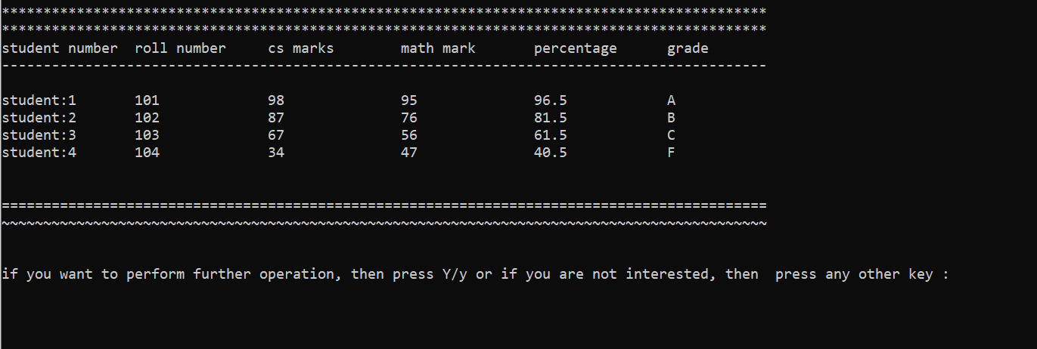

**File Handling**

* The latest record is always stored in **data.txt** for persistence.

**Console Customization**

* Choose colors (Green, Aqua, Red, Purple, White) at startup.
* Progress bar style loading animation before UI color selection.

**Demonstration Videos**

To provide better clarity and verification of the project, two demonstration videos have been recorded:

1. **01_Code_Overview.mp4** – Explains the complete code structure, functions, and logic used in the project.
2. **02_Functionality_Demo.mp4** – Shows the execution of the program, including testing of all functionalities.

**Author**

**Muneeb Hussain** – BSCS Student